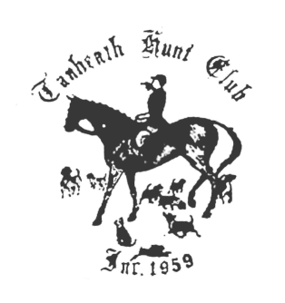
Tanheath Turkey Trot Entry Form November 13, 2016

Please Print

Name _________________________________________________________

Address _______________________________________________________

Email ____________________________ Phone________________________

Name _________________________________________________________

Address _______________________________________________________

Email ____________________________ Phone________________________

Check payable to TANHEATH HUNT CLUB: pre-entry $40, lunch included.
Post-entry $45, lunch may be purchased $8 while supply lasts
Send pre-entries to:
Leslie Cashel
10 Tanglewood Dr.
Greenville, RI 02828
Questions: lecashel1@msn.com or 401-949-2910

Entry form is not valid unless accompanied by signed liability release form for each rider. Minors under age 18 must have liability form signed by parent or guardian, not by trainer.

Liability form can be found on out webpage, www.tahheathhunt.com

Entry form, payment, and liability form must be received by mail by Nov 9th to be considered pre-entry. Verbal or e-mail intent of participation is not a pre-entry.

