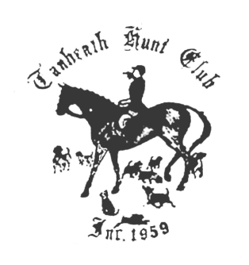
TANHEATH HUNT CLUB TURKEY TROT

Gager Hill Road, Scotland, CT, November 13th, 2016
Parking will be in a field and there will be signs

The Turkey Trot is an 7 mile pleasure ride through woods and fields.
No jumps
Western or English riders can go individually or as a group.
Start between 9:30 AM and 12:00 PM Rain or shine

If you find a hidden paper plate with a picture of a turkey on it and return it to registration you will receive a real frozen turkey.

Note: Hard hats are required. Bring your own water.

Pre-entry $40 – includes big lunch.
Entry fees must be received no later than the Thursday before the ride to be considered pre-entry.

Post-entry $45 – lunch may be purchased for $8 while supply lasts

Checks payable to Tanheath Hunt Club and send to:
Leslie Cashel
10 Tanglewood Dr
Greenville, RI 02828
401-949-2910
Lecashel1@msn.com

Directions: CT route 14 to route 97 south. Gager Hill Rd is first right off route 97.
Signs on Gager Hill Rd will direct you to parking in field on right.

