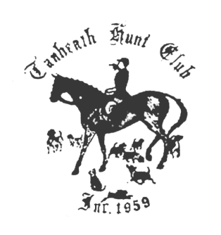

TANHEATH HUNTER TRIALS

Saturday, November 21st,2016, at Ayer Mountain Farm, 55 Ayer Mountain Rd, Franklin, CT.
Rain date, November 22nd.
Start 10 – 11 AM
No pre-registration.
Hunting attire is requested

The course is 2-3 miles long and includes parts of the cross country course and wooded trails surrounding the farm.

Jumps are optional for all divisions.

Riders may be asked to perform events for extra points such as:
Gone Away – gallop on
Hold Hard – Stop quickly
Take designated jumps

Entry fee for each division is $20. Riders may enter multiple divisions.

Divisions:
Open division- open to all – judged on fastest time
Ladies division – women riders only – ideal hunt pace
Men’s division – male riders only- ideal hunt pace
Junior division – riders 18 and under- ideal hunt pace
Qualified division – Tanheath members only
Riders and horses that have ridden in at least
3 Tanheath events, ie hunts or paces or sponsored rides
Ideal hunt pace

Ribbons and trophies to be presented at the Master’s Dinner, December 3rd.

Questions: contact Cathy Leinert 1/860-867-7063. rottrsq@concast.net

