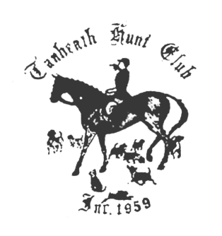
TANHEATH HUNT CLUB

RIDE FOR THE PRIZE

SUNDAY AUGUST 28, 2016

HODGES VILLAGE DAM, OXFORD, MASSACHUSETTS

9 AM TO 12 PM, RAIN OR SHINE

PRE-ENTRY FEE $40 per rider, ENTRY DAY OF $45 per rider

New England Horse & Trail Association (NEHT) eligible

The ride is approximately seven miles long. There is a water crossing.

Small gift bags will be hidden along the ride. If you spy one of these and retrieve it you will be awarded a large bag filled with prizes at the end of the ride.

NOTE: HARD HATS AND BOOTS ARE REQUIRED.

Bring your own water. Coggins and rabies verification must be available on request. Entry forms and liability forms must be received no later than the Wednesday before the ride to be considered a pre-entry. See www.tanheathhunt.com for entry and liability forms. Riders under 18 must have a parent or guardian (not trainer) sign liability form.

Checks should be payable to:
TANHEATH HUNT CLUB and sent to:
Leslie Cashel
10 Tanglewood Dr
Greenville, RI 02828
401-949-2910
lecashel1@msn.com

Directions to Hodges Village Dam: Route 395 to exit 4 West toward Oxford. Cross over route 12.
Go past Howarth Road and turn right on OLD Howarth Road. Signs to ride will be on the right.

